FAD Program outline and guide

What is FAD?

The Flourish! Food Aggregation and Distribution Program is designed to make ordering groceries easy and affordable for schools. Our program distributes fresh fruits and veggies, breakfast foods, and ready made snacks to schools across Greater Victoria. Schools order groceries via our online marketplace and orders are delivered the following Tuesday and Wednesday by our drivers.

Schools have from 7am Wednesday until 12pm Friday to place orders for the following week.

FAD orders are packed on Monday and Tuesday afternoons in the Flourish Kitchen Area (table space will not be available until 11-11:30). Monday packaging takes about 2-3 hours with 1 person. Tuesday packaging takes 2-3 hours with 2 people (Bruce or Thor will help).

How to manage the marketplace
The online shop is built using the Local Food Marketplace. In our manual we have specific training videos for our admin system that were provided us during onboarding.

They have been redacted here, as we cannot provide you with administrative access to manage our account.

To access the marketplace you will need to have an Admin account made for you.

Each school has been given an account pre-loaded with their funding for the year (with some exceptions)

School accounts are managed by a “point person” in the school who will place orders and be your main communication person regarding FAD. The school and contact person can be found under the “Customers” tab, as the contact person for each school.

If you need to create or manage products watch Training 2.

Orders are found under “Orders -> Orders”. Training 3 has everything you need to know to manage orders.

Ordering groceries for FAD

You will need to order groceries to “refill inventory” each week. Use the document linked below to find out what days orders need to be submitted on, how to log in, and when orders will arrive.

We have redacted ordering details as this includes personal contact information for our multiple suppliers.

On long weekends all orders will need to shift a day earlier.

Other specific details about our suppliers are provided here, but have been redacted for privacy.

Once the ordering window closes on Friday you can look through the orders and make sure you have enough inventory to fill them.

Packaging Orders

When you are ready to pack orders, print packing slips for each school by selecting all orders placed in the period which you are packing.

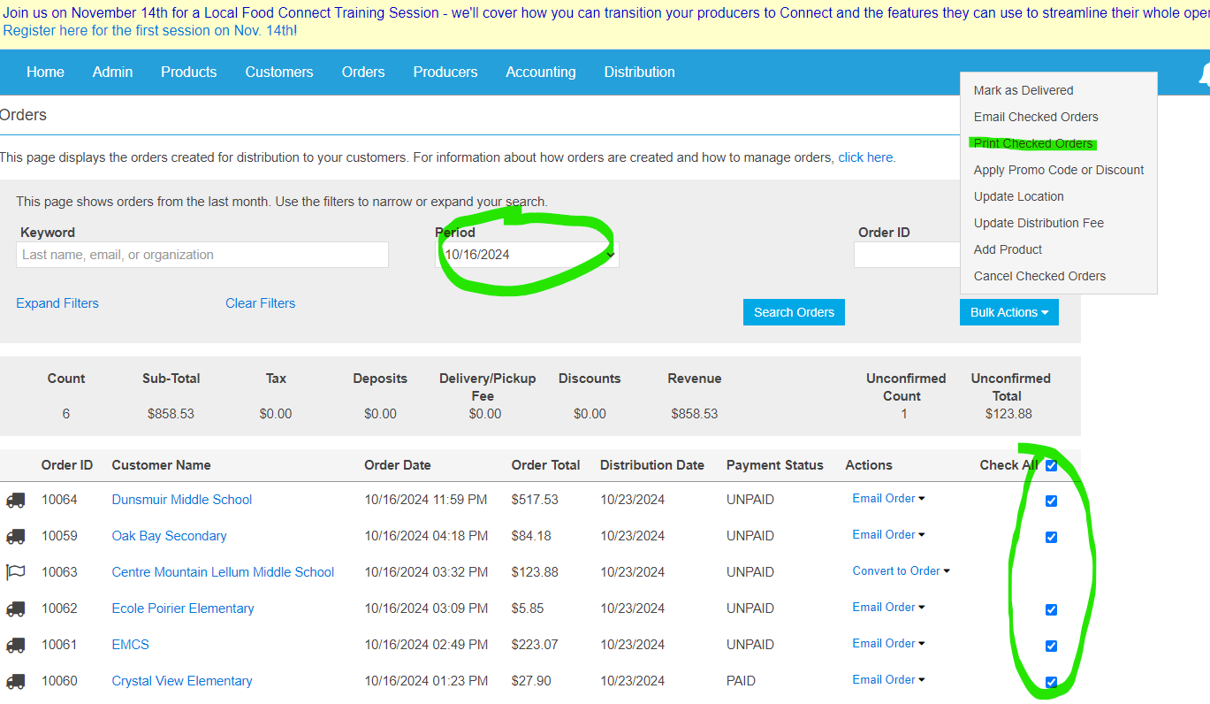

Using the “Bulk Actions” Button, print your packing slips and then sort school orders into piles for Tuesday and Wednesday for each driver.

Once you have your orders sorted by date and driver you are ready to pack them. Local Food Marketplace has a really handy packing function.

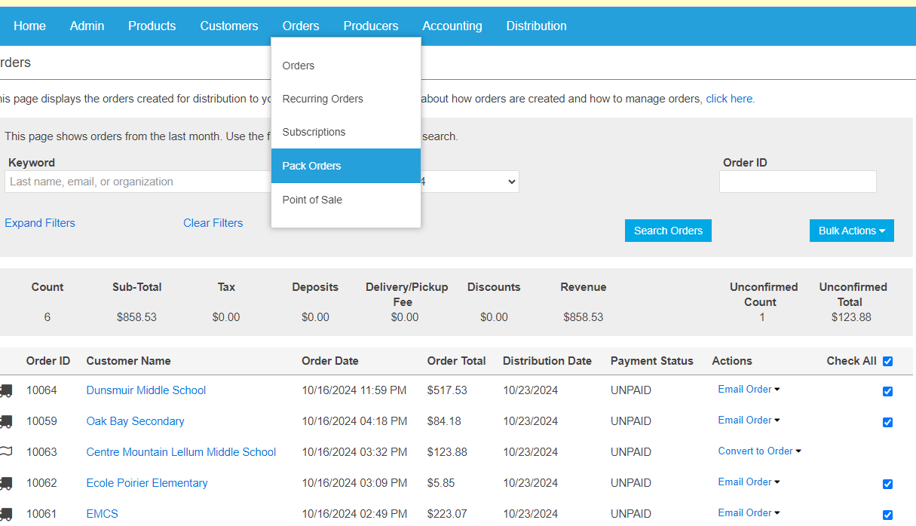

This will bring you to a page that allows you to sort by orders or products. Choose the schools you want to pack today (advanced filters allow you to select specific “customers”) and then sort by “product” and use this list to collect all the items in your orders and load them onto carts. You generally want one cart for dry goods and one for cooler items.

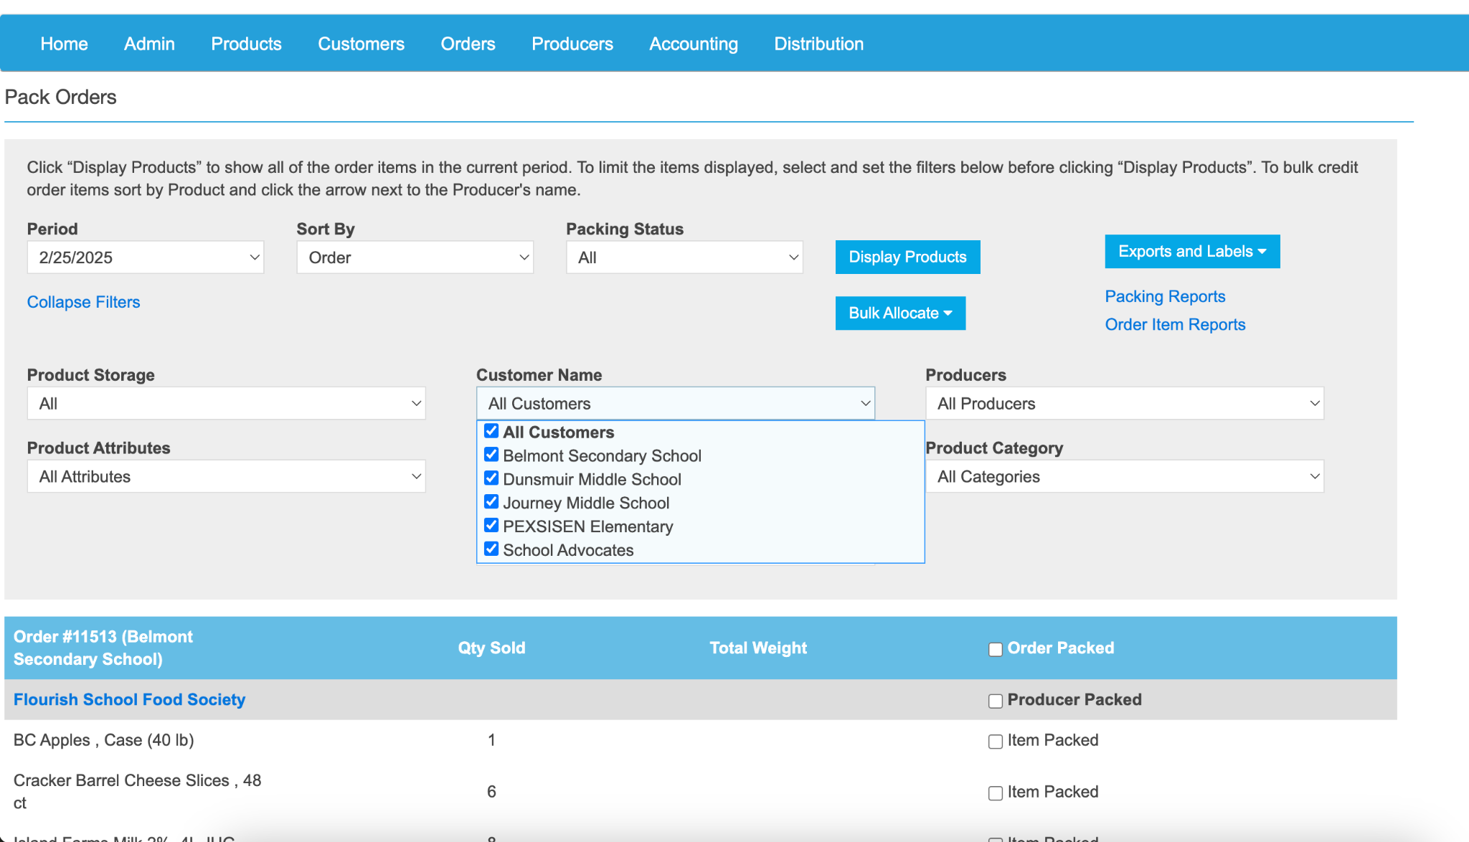

Orders are packed into Frog Boxes or banana boxes and labeled with the school name. Pack the orders into as few boxes as possible (feel free to use other boxes if they make more sense, ie, if a school orders 12 boxes of kashi granola bars, just label and send a full case, instead of unpacking and repacking the items into a new box.) Frozen Items will need to be packed in the morning ahead of loading the trucks, leave clear notes on bins awaiting frozen goods and communicate to the drivers if they need to collect things from the freezer.

Fill in a delivery sheet for each driver with the schools they will be going to on a given day, and the number of boxes, milk crates, etc. So they know what they are expected to drop off at each stop.

